ÖDEV

HR.EMPLOYEES tablosu dataları kullanarak   
  
1-Departmandaki tüm çalışan personelleri yanyana yazabilir misiniz?

 ISIM SOYISIM;ISIM SOYISIM....

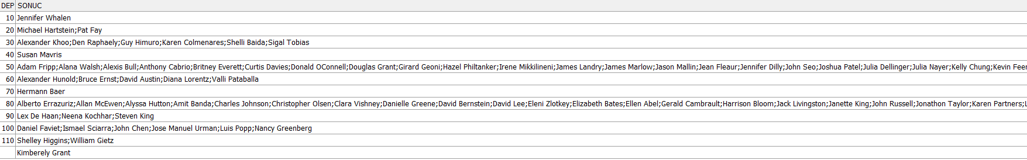  
SELECT department_id, LISTAGG (first_name || ' ' ||last_name, '; ')

WITHIN GROUP (ORDER BY department_id)

AS sonuc FROM

hr.employees GROUP BY department_id

2- JOBID YE GORE GRUPLANACAK  
 EMPID YE SIRALANACAK GORE HERKESIN KENDINDEN 1 ONCEKI VE 1 SONRAKI  
SALARY TOPLAMI BULUNACAK

select hr.employees.*, SUM(salary) OVER (PARTITION BY job_id ORDER BY

employee_id ROWS BETWEEN 1 PRECEDING AND 1 FOLLOWING) NUM from hr.employees

3-TELEFON NO HERKESIN KENDINDEN BIR SONRAKI KISININ TELEFON NUMARASINI  
YANINA YAZIN  
HIRE_DATE E GÖRE SIRALI  
DEPARTMENT_ID göre gruplanmalı

select hr.employees.*, LEAD(phone_number,1)

OVER (PARTITION BY department_id ORDER BY hire_date)

NEXT_VALUE from hr.employees  
  
4-MAASLARA GORE 1 DEN BASLAYARAK SIRALA EMPLOYEES TABLOSU ICINDE  
MAAS AYNI ISE KIDEME(İŞE GİRİŞ TARİHİ) GORE SIRALA

SELECT

hr.employees.*,

RANK() OVER (ORDER BY salary DESC, hire_date ASC) salary_rank

FROM

hr.employees

ORDER BY

salary_rank;  
  
5-TÜM TABLOYU EMPLOYEES ILK 10 İÇİN 1 DIGER 10 İÇİN 2... YAZACAK. Sıralamayı EMPLOYEE_ID üzerinden yapabilir misiniz?  
NTile fonksiyonunu kullanırken Order_Clause da olmalı.

select hr.employees.*, NTILE(11) OVER (ORDER BY employee_id) from hr.employees

6-HER DEPARTMAN İÇİN ORTALAMA MAAŞIN ALTINDAKİLER 0 ÜSTÜNDEKİLER 1  
OLARAK GÖSTERİLSİN.

SELECT employee_id, salary, department_id,

CASE

WHEN salary < avg_salary_over_dept THEN 0

ELSE 1

END AS salary_label,

avg_salary_over_dept AS avg_salary_department

FROM (SELECT employee_id, salary, department_id,

AVG(salary) OVER (PARTITION BY department_id) AS avg_salary_over_dept

FROM hr.employees

) t

ORDER BY

department_id, employee_id;

7- employees tablosu yıl içinde işe başlayan ilk personelleri listeleyebilir misiniz?

SELECT e.*

FROM hr.employees e

JOIN (

SELECT employee_id, hire_date

FROM ( SELECT employee_id, hire_date,

ROW_NUMBER() OVER (PARTITION BY EXTRACT(YEAR FROM hire_date) ORDER BY hire_date) AS rn

FROM hr.employees

) ranked_employees

WHERE rn = 1

) first_employee_per_year

ON e.employee_id = first_employee_per_year.employee_id

AND e.hire_date = first_employee_per_year.hire_date;

8- Her departmanda en yüksek ücret alan personel dışındaki tüm kayıtlar gelsin.

SELECT *

FROM hr.employees

WHERE employee_id NOT IN (

SELECT employee_id

FROM (

SELECT

employee_id,

DENSE_RANK() OVER (PARTITION BY department_id ORDER BY salary DESC) AS salary_rank

FROM hr.employees

) ranked_employees

WHERE salary_rank = 1);

9- Her departmanda en yüksek ücret alan 2 personelin kayıtları gelsin.

SELECT *

FROM hr.employees

WHERE employee_id NOT IN (

SELECT employee_id

FROM (

SELECT

employee_id,

DENSE_RANK() OVER (PARTITION BY department_id ORDER BY salary DESC) AS salary_rank

FROM hr.employees

) ranked_employees

WHERE salary_rank > 2);

10- Her departmanda en kıdemli personelden başlayarak ondan önce ve sonra bölüme başlayan pesronelin ad soyad bilgisini gösterebilir misiniz

SELECT

department_id,

first_name,

last_name,

hire_date

FROM

( SELECT

department_id,

first_name,

last_name,

hire_date,

RANK() OVER (PARTITION BY department_id ORDER BY hire_date) AS rank

FROM hr.employees) ranked_employees

ORDER BY department_id,

CASE

WHEN rank = 1 THEN 0

ELSE 1

END,

hire_date;